Enabling Tax tracking for Orders and Invoices

PPC Maintenance > Create Sales Tax as an Account
- Create New Account name: Sales Tax
- Check Tax box.
- Enter Account number if needed for Accounting exports.
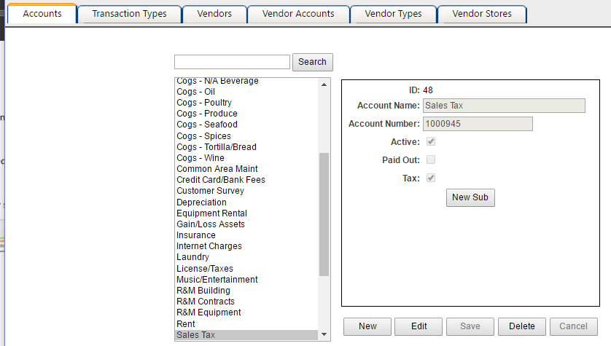

Assign Sales Tax Account to Vendors
- PPC Maintenance > Vendor Accounts
- Assign Sales Tax account to all vendors needing to track Sales Tax.
Currently Decision Logic only supports 1 tax account per vendor.
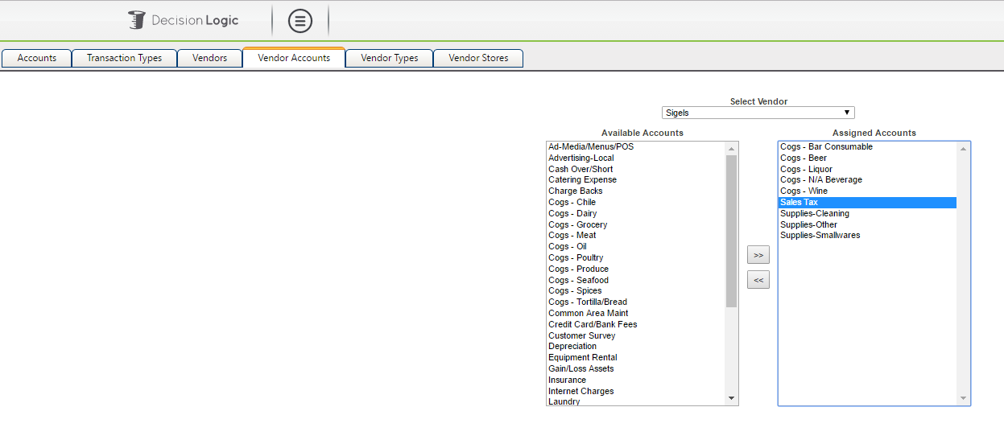

Enter Manual Receive
- Ordering Home > Enter Manual Receive
- Select Receive Method: Receive from an Order Guide
- Select the Distributor to Receive from
- Check Create invoice
  - It is not necessary to select Vendor to apply cost. That will be inherited from the PPC Vendor mapped to the Distributor in Distributors maintenance.
- Enter Amount as total invoice amount (including tax)
- Enter Tax as tax amount from the invoice
In the example below the Amount is 117.00 and 17.00 of that 117 is the $ amount of Tax incurred on the invoice.
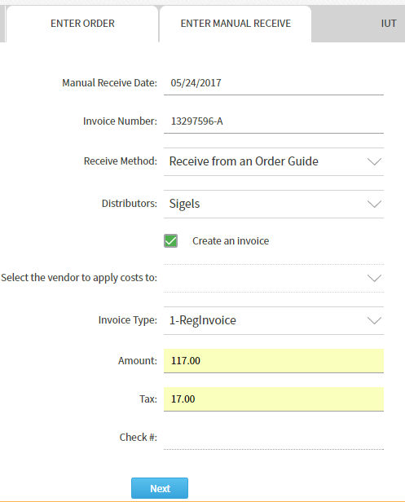
- Select Next to proceed to the Order Guide
- Begin Adding Quantity of items to be received
  - Select Next or a different location from the drop down to add more items
  - Items will display in the Location and order which they are set under Ordering Home > Guide Set Up.
- Change Price as needed.
  - Initially the Diff $ will be displayed as 0.00
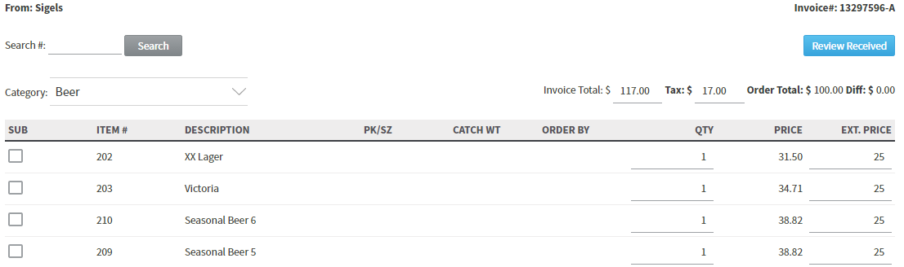
- Select Review Received
  - Order Total + Tax should match invoice total.
  - Difference will show in red and should be the same amount as tax amount.
  - Disregard the red notification and post the order.
- A success notice will appear when posted.
- Proceed to review or export the invoice.
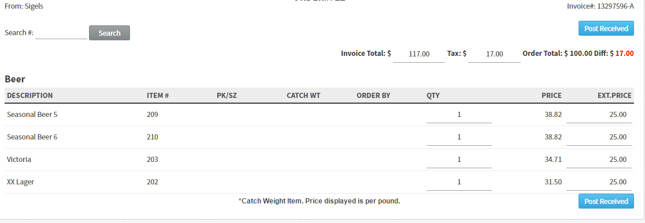
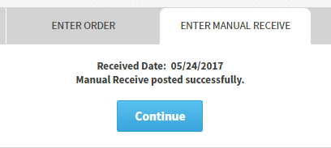

Review or Export the Invoice

To review the Invoice
navigate to Invoice History > View invoice
Invoice will display with Sales Tax amount

To Export the Invoice
Navigate to Exports > PPC Invoices
- Select your parameters in the Invoice Export interface.
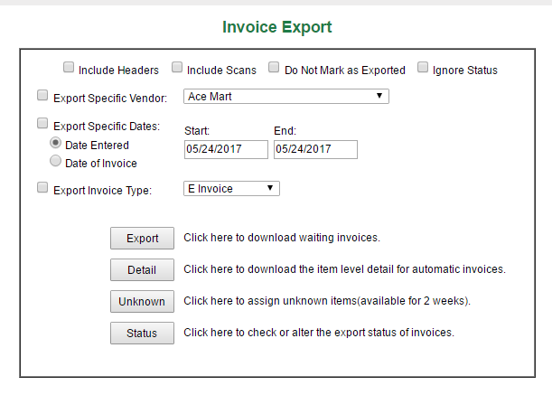
- Select Export
  - An Excel file will download.
- Open the excel file.
  - Invoice Export will contain a separate line for Sales Tax

