Mobile Waste Sheet
V 3.16

Mobile Waste Sheet

Waste sheet app has been put in place for managers to record waste by ingredient or menu item.
- Log into the DL Mobile Toolkit and select Waste Sheet.

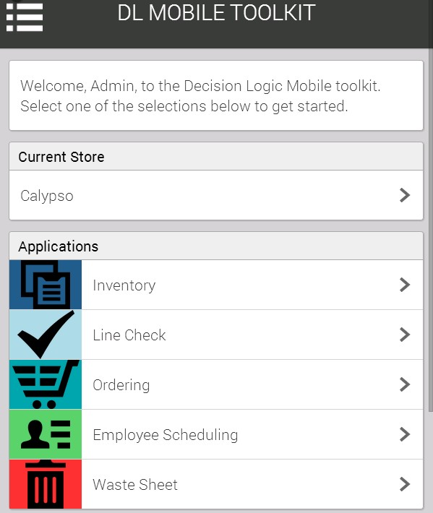

- Select the proper date to enter wasted item.

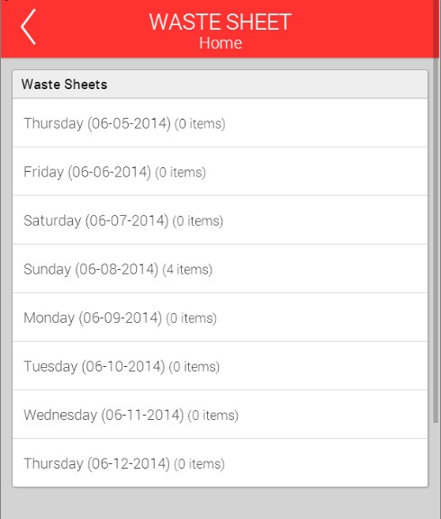
- Determine if the item wasted is a menu item or an ingredient.
- Select Add new ingredient or menu item.
- Search for the item wasted by entering name in the search box and selecting enter or search

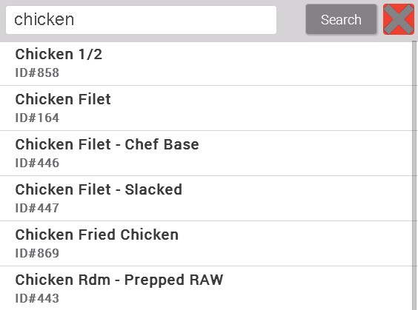

- Select Item wasted
- Enter the reason for the item being wasted, the quantity wasted and any comments that are related.
  - QTY can be entered by the recipe value or the inventory value.
    - Recipe value can be used when quantity wasted is smaller than a case.
    - Inventory value can be used when quantity wasted is a case or more.
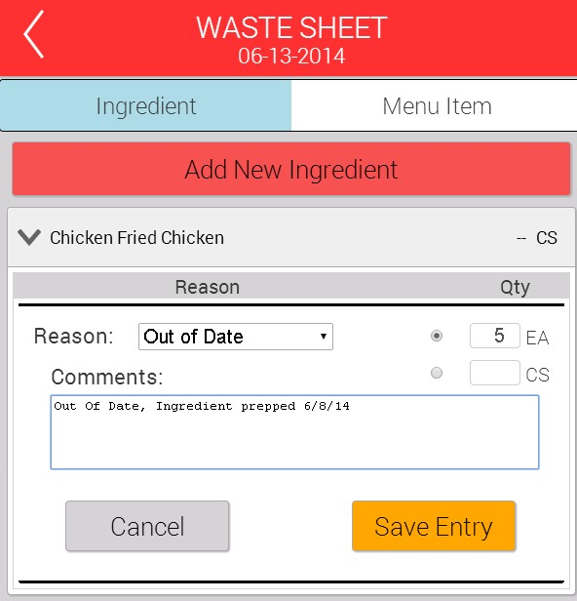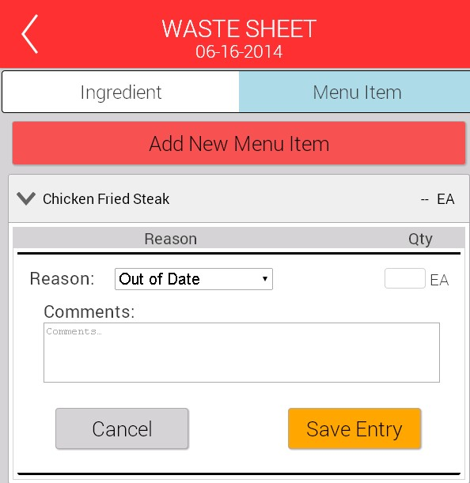

- Select Save Entry
- After saving the items entered are available for viewing.
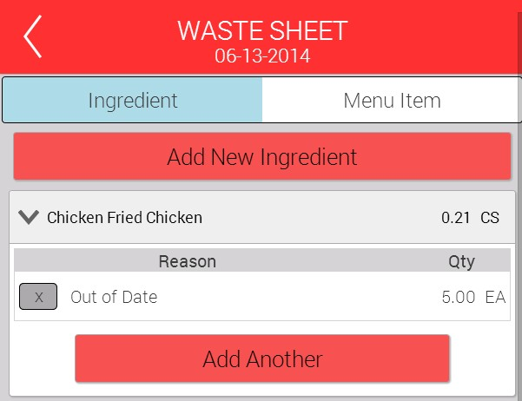

- After an ingredient or menu item is added the option to “add another” is available. Select this to add an additional ingredient. In example above Chicken fried Chicken.
- If needing to add another item that has not yet been started select add new ingredient or menu item.
- Select the X if entry needs to be deleted.

